**HOME PAGE**

* **First super speciality** hospital in Kavali.
* Providing compassionate, quality healthcare to our community for over **25 years**.

50,000 successful surgeries

25 + years of care

85,000+ patients cured

(Remove Specialities)

**Dr. Manchikanti Ramaswamy**

Founder & CEO

Kavali’s very **first Orthopaedic Surgeon**, with over **50,000 successful surgeries** to his name, he has dedicated his life to restoring mobility and transforming lives. Guided by the timeless words of his mentor, Dr. SSK Marthandam, he lives by a principle that continues to inspire our entire team: **“Don’t run behind money — work with such dedication that money runs behind you.”**  
His message to every member of our hospital family remains simple yet profound — “Live with ethics, values, and relationships.”

**Excellence in Healthcare**

1. **Experienced Team**

At Dr. Ramaswamy Hospitals, our strength lies in our team of **highly qualified and experienced medical professionals** who are dedicated to delivering exceptional patient care. From skilled surgeons and specialized consultants to compassionate nurses and support staff, every member of our team works with commitment, precision, and empathy. With years of hands-on experience and continuous training, our experts ensure that each patient receives the highest standard of treatment, backed by advanced medical technology and personalized attention. Together, we strive to uphold our legacy of trust, care, and excellence in healthcare.

1. **24/7 EMERGENCY CARE**

Our emergency team is **always ready—day or night—**to provide swift, expert care when it matters most. With skilled doctors, trained nurses, and advanced facilities, we’re here every moment to save lives and support patients in critical times.

1. **PATIENT CENTRED APPROACH**

Our team is dedicated to delivering care that truly revolves around our patients. **We listen, understand, and work together** to provide compassionate, personalized treatment that ensures comfort and trust at every step.

1. **AFFORDABLE CARE**

The team is dedicated to providing quality treatment at a **cost everyone can afford.** We combine compassion, expertise, and care to ensure every patient receives the best without financial burden.

1. **COMPREHENSIVE SERVICES**

Our doctors, nurses, and support staff work together to **provide seamless, patient-centred care**. With expertise and compassion, we ensure every patient receives the best treatment and attention at every step.

**ABOUT PAGE**

Dr. Ramaswamy Hospitals is **Kavali’s first super-speciality hospital**, founded by Kavali’s **first Orthopaedic Surgeon** with over **50,000 successful surgeries**. With 25+ years of trusted service, we’ve introduced many healthcare firsts — from advanced ICUs and dialysis care to 24/7 medical support. Guided by strong ethics and compassion, we continue our mission to provide **quality, affordable, and patient-focused care** to every individual who walks through our doors.

50,000 successful surgeries

25 + years of care

85,000+ patients cured

24/7 Emergency Care

(Remove specialities)

**MISSION & VISION**

1. **Our Mission**  
   At Dr. Ramaswamy Hospitals, our motto is “To care and to cure.” We are committed to providing high-quality, affordable healthcare for everyone. Our focus is on delivering advanced medical care with compassion, ensuring safety, comfort, and excellence. We value every patient’s trust and feedback as we continue to improve our services. With ethics and empathy at our core, we strive to be the most trusted healthcare partner for families in Kavali and beyond.

**Vision**

To be the leading healthcare provider in the region, recognized for exceptional medical care, compassionate service, and our commitment to improving community health through quality treatment and health awareness initiatives.

**Motto**

Our hospital’s motto is **“Care and Cure.”** We are dedicated to providing high-quality healthcare to every patient, offering compassionate support to those in need, and continuously improving our services based on patient feedback.

**Core values**

Same

**Leadership Team :**

**Dr. Manchikanti Ramaswamy**

Founder & CEO

Kavali’s very **first Orthopaedic Surgeon**, with over **50,000 successful surgeries** to his name, our founder has dedicated his life to restoring mobility and transforming lives. Guided by the timeless words of his mentor, **Dr. SSK Marthandam**, he lives by a principle that continues to inspire our entire team:  
**“Don’t run behind money — work with such dedication that money runs behind you.”**  
His message to every member of our hospital family remains simple yet profound — “Live with ethics, values, and relationships.”

**Mr. Manchikanti Venkata Sowrav**

Director

Our Director believes that a hospital is not just about treatment — it’s about the people who are cured.With a strong sense of care and responsibility, he makes sure every patient who walks in feels supported and every staff member feels valued. His focus has always been to continue the hospital’s legacy built on **trust, ethics, and compassion.** For him, **true success does not lie in numbers, but it lies in the smiles of patients who leave healthier and happier.**

**Our Facilities**

Remove it.

**Photo Gallery**

<https://we.tl/t-emUITbZ6ln>

**SERVICES PAGE**

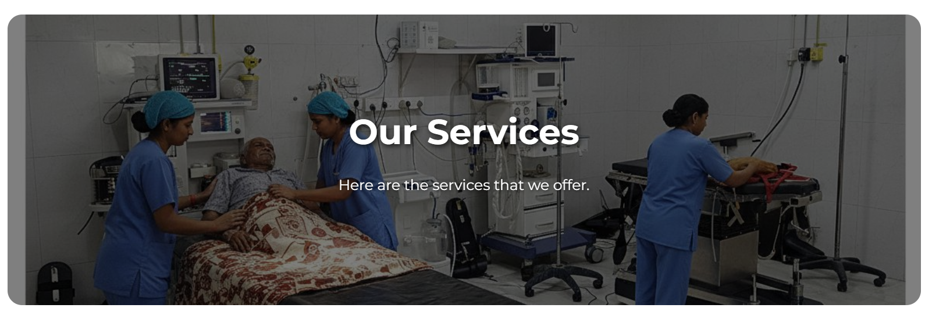

The other picture should come here ra. This one 👇

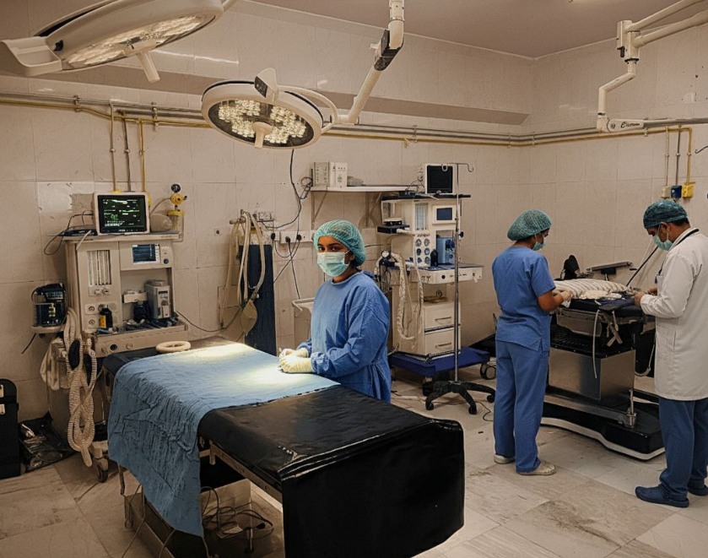

OUR SERVICES – Here are the services that we offer.

1. General Medicine - General Medicine department, we are equipped with ECG, ECHO, equibilator, inotropic syringe pumps, ventilators, succession tubes, with all ICU facilities to cure emergencies, our present physician in good at handling Cardiac, cerebral cases, all pulmonary cases, all types of fevers and chronic diseases like diabeties, hypertension and thyroid – Dr.Pushpika
2. General Surgery - General surgery includes open appendix, open gall bladder surgeries, bowel injuries, spleen-ic injuries, blood trauma abdomen, our hospital is expertised with a surgeon who also does lap appendix, lap coleen, lap hysterectomy, lap ovarian cyst, lap tubectomy, lap ectobic surgeries, lap hernia repair, open thyroid surgeries, and other small cystic surgeries.
3. Orthopedics - our main branch is Orthopedics run by Dr. Ramaswamy with 25 years+ experience who does Trauma, Replacements, Spine Surgeries ,Revision Replacements, Orthopedic bone tumors and surgeries, tendon transplants, flap closures, shoulder scopies, knee scopies, shoulder replacements, and all types of paediatric ortho surgeries, deformity corrections and abdomen.
4. Urology
5. Neurology
6. Nephrology - Nephrology is run by Dr. Surendra who takes care of renal patients and he takes care of all the dialysis patients and acute renal and chronic general cases.

**Our Doctors**

1. **Dr. M. Ramaswamy**

M.B.,B.S,,M.S.,M.Ch. (Ortho)

1. **Dr. Pushpika**

DNB Family Medicine

IDFCC – Diabetes

PGDIP – Rheumotology (UK)

MRCGP - AKT

1. **Dr. Surendra**
2. **Dr. Jaheer Basha**

M.B.B.S.

**5. Dr. Gorantla Padmavathi**

M.B.B.S.

Doctors pictures - <https://we.tl/t-go3tmPtXdL>

**Facilities**

1. 50+ beds – A/C and Non- A/c rooms
2. Dialysis - First of it’s kind, Dialysis centre with around 750 Dialysis per month.
3. ICU – Mention first in Kavali
4. Theatre is equipped with all types of monitors, ventilators, higher end C-Arm machines, laporocopy set, Endoscopy and colonoscopy set, Arthoscopy set.
5. We have a fully automated horizontal Sterlizer.
6. Very own RO Plant
7. Underground Parking
8. Lab has fully automated bio chemistry analyser, electrolyte sterlizer, ABG analyser, a fully automated Cell counter, a separate counter for PT, APTT,INR. A separate machine for thyroid, Elyssa reader with highly qualified technicians doing their job.
9. We have a higher-end digital X-ray which is taken care by highly trained staffs along with this we have trained staffs in all the departments to overcome the needs of the patient, to care about the services given to the patients.
10. we have around the clock duty doctors to serve and take good care of the patients.
11. Others are same

**Achievements**

1. ISO Certified
2. Attached with major TPA’s.
3. Corporate Medical Partner for Infosys

**Contact & Location (Remove the sub paragraph)**

**Address**

Same

**Phone**

+91 9912757854 (only this number)

Please note that we do not take appointments beforehand.

**Email**

[ramaswamyhospitals@gmail.com](mailto:ramaswamyhospitals@gmail.com)

**Hours**

same